The Honourable John Horgan, MLA ([john.horgan.MLA@leg.bc.ca](mailto:john.horgan.MLA@leg.bc.ca))

Premier of British Columbia

PO Box 9422 STN PROV GOVT

Victoria, BC, V8W 9V1

Dear Premier Horgan:

Subject: BREACH OF MEDICAL PRIVACY – VACCINATION STATUS

It has come to my attention that a serious breach of medical privacy is occurring with the Immunize BC Vaccination Status Indicator.

The Immunize BC Vaccination Status Indicator (<https://immunizebc.ca/vaccination-status-indicator>) permits a BC citizen’s vaccination status to be disclosed with only a BC Health Card number along with date of birth.

The fact is BC parents are routinely required to provide their children’s BC Health Card number(s) and date of birth upon registration for schools, day cares, sports clubs, etc. This means that a child’s private medical information is available to ANYONE with access to this information without the express consent of the parent or individual.

Here is an example of what is revealed to anyone entering this information:

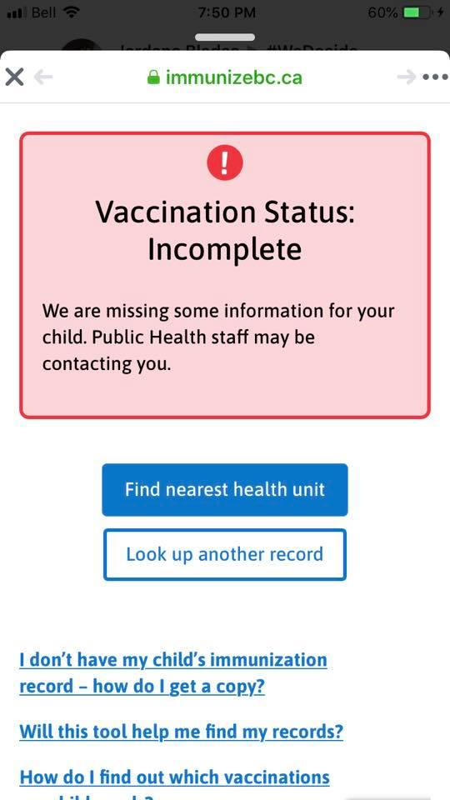

This is a very serious breach of medical privacy that needs to be addressed immediately.

I demand that the Immunize BC Vaccination Status Indicator be immediately suspended until such time as appropriate safeguards are in place to ensure medical privacy.

I look forward to your considered response in how you intend to address this breach of medical privacy.

Sincerely,

CC:

**Adrian Dix**, Minister of Health [HLTH.Minister@gov.bc.ca](mailto:%20HLTH.Minister@gov.bc.ca)

**Michael McEvoy,** Information and Privacy Commissioner for BC

[info@oipc.bc.ca](mailto:info@oipc.bc.ca)